* After creating the volume, we must attach to the instance. By clicking on the active button there is option for the attach volume. 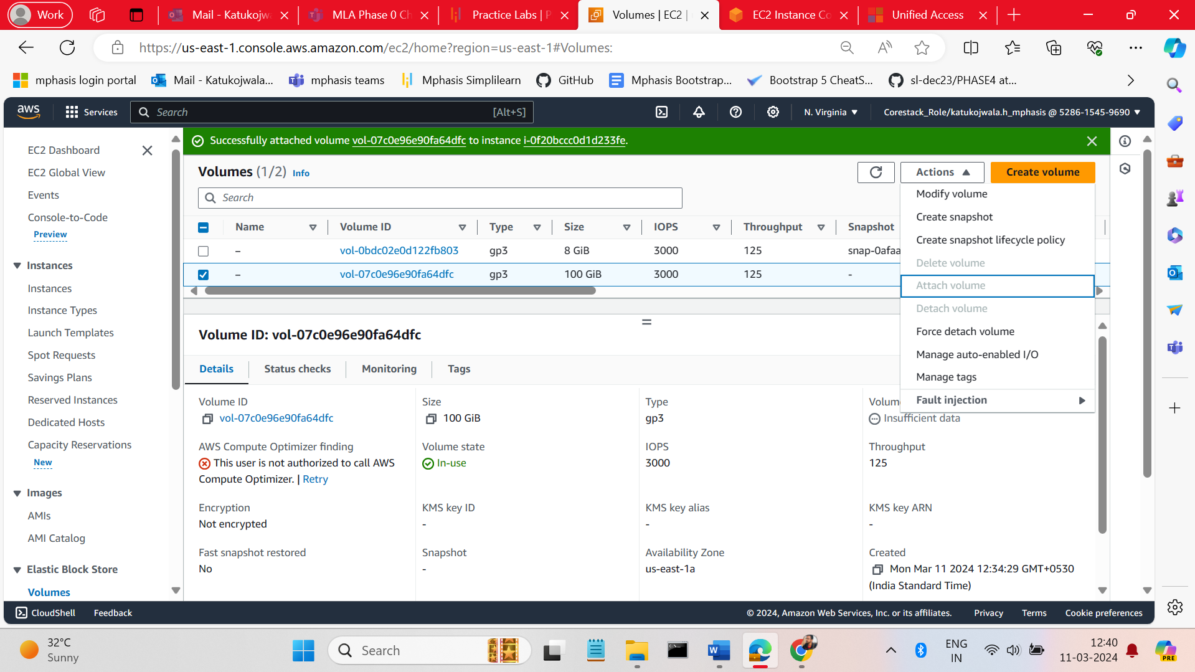
* Connect to the instance and get the volume name by giving the commend name **LSBLK** in commend prompt. Give all volume listed 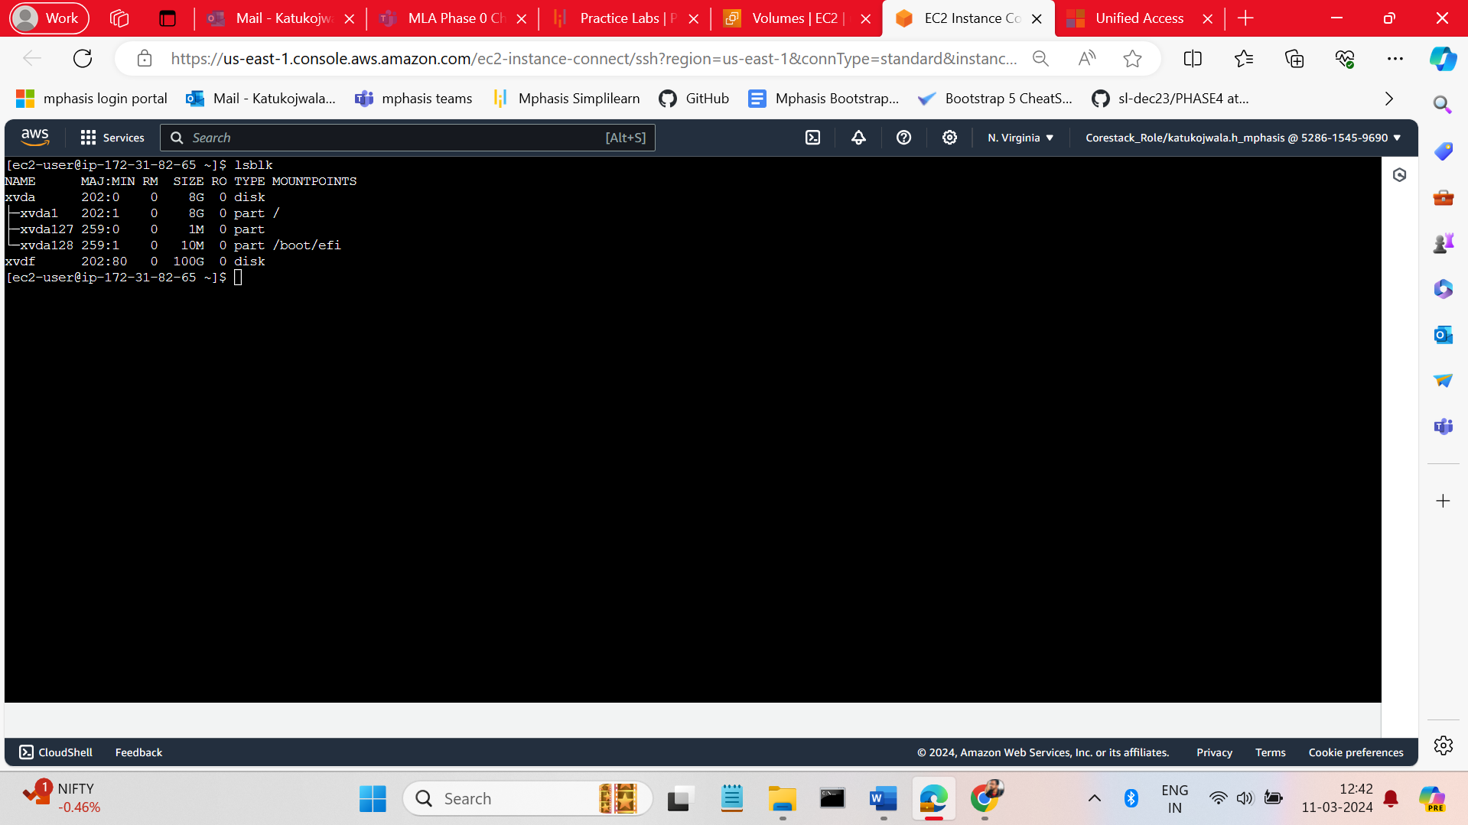
* For the formatting give the commend sudo mkfs -t ext4 /dev/volumename 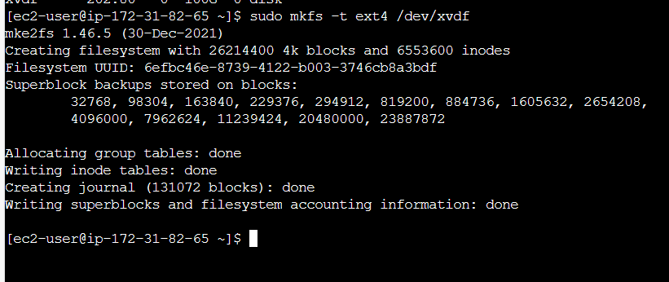
* For the mount we must create new volume the we do mount.

1. Sudo mkdir /dev/newvolume/
2. Sudo mount /dev/volumename /newvolume/

